TITLE

THE DATE

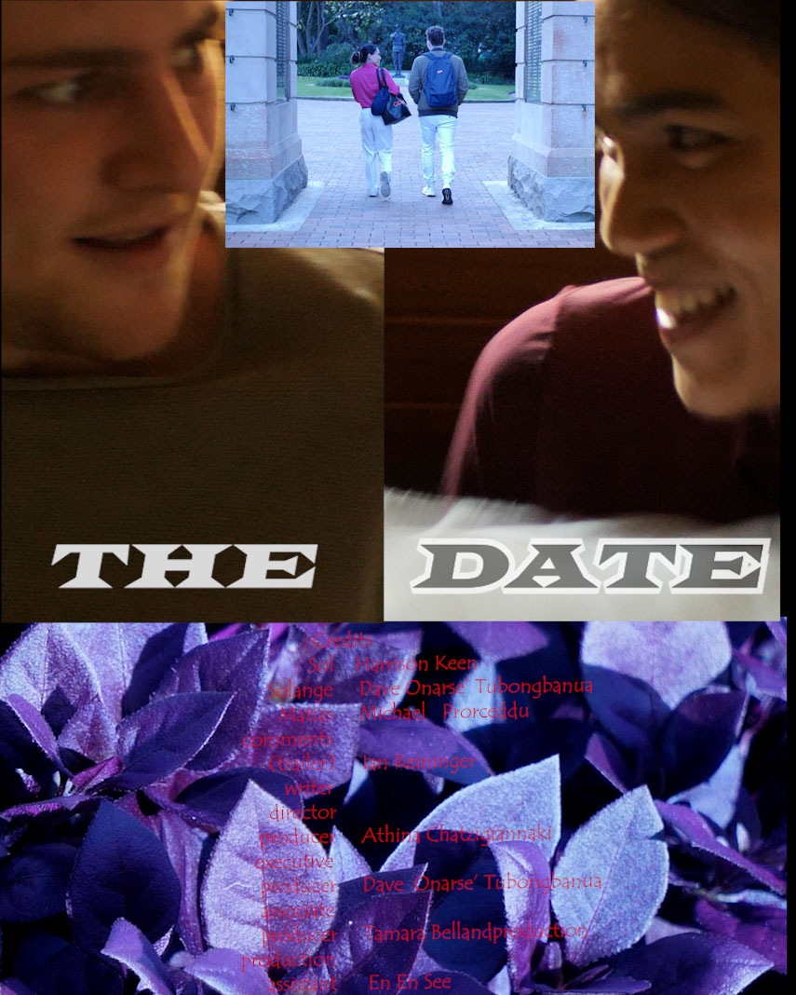

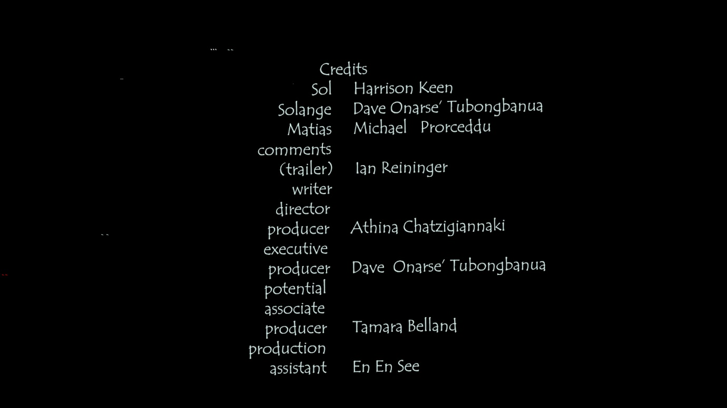

Production 2023

Logline
Will Sol and Solange manage to break through patterns of behaviour and culture and truly connect?

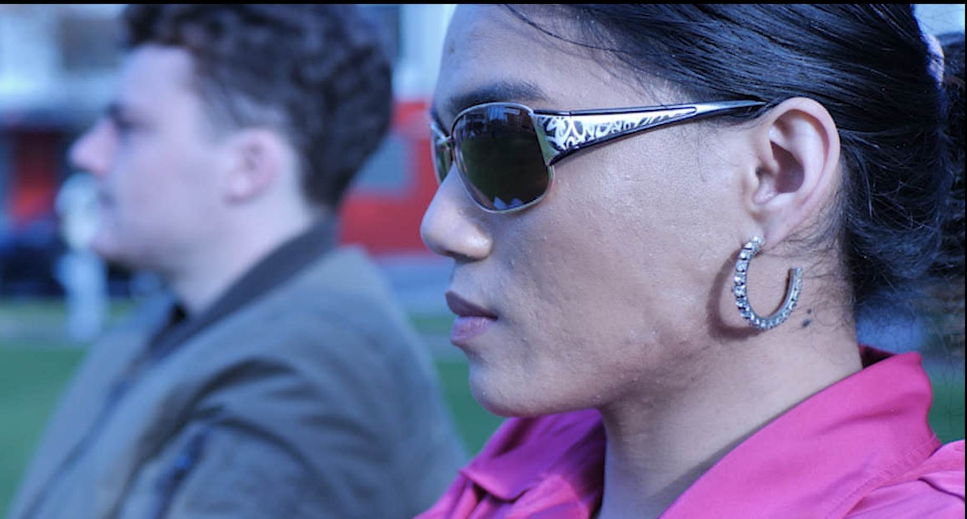

Short Synopsis
Sol, who lives in a holiday place, is very excited about his new acquaintance. Solange, just arrived on her long-term break from work. They are both willing to take a chance to bring things between them to another level, however, that proves quite challenging, since unexpected impulses kick in…

Character description

Solange
She is Philippinese, living and working as a journalist in the Middle East. This brings her in a position of great awareness of women’s struggles for emancipation and rights on the one hand, arranged marriages on the other, although she enjoys a balanced position in relation to men as the norm in her own country.
However, even for her, establishing an intimate relationship in the modern world has proven tricky.
So, when this challenge with Sol shows up for a fresh start, she doesn’t hesitate to refer to a book for advice on how to do things right this time. Yet, the stream of life takes over, making her experience, a unique flow of events.

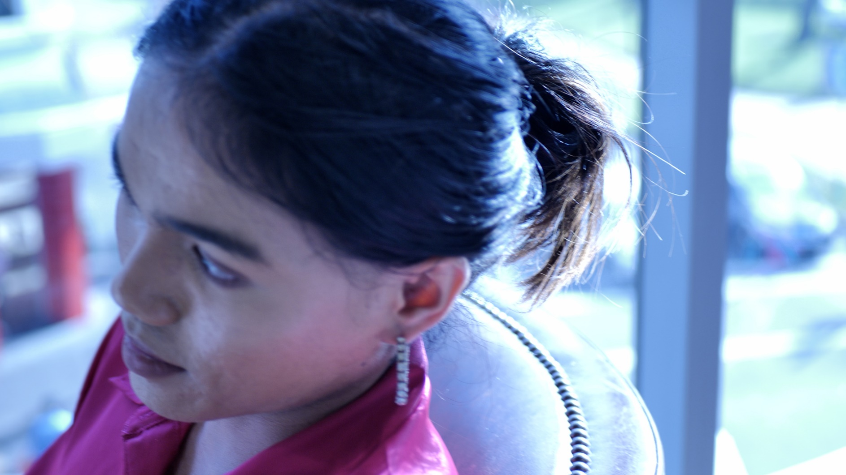

Sol
He has a controversial personality. He is looked upon as being shallow in his love affairs and not serious in his encounters with the other sex, but a pure and genuine core in his being comes to surface this time and he takes a chance, a leap in faith (as well as Solange).Matters tend to fall out of plan, in a way that makes us wonder: will he save the day after all? Or we are simply allowed to create our own version of outcome, after the end of the film…

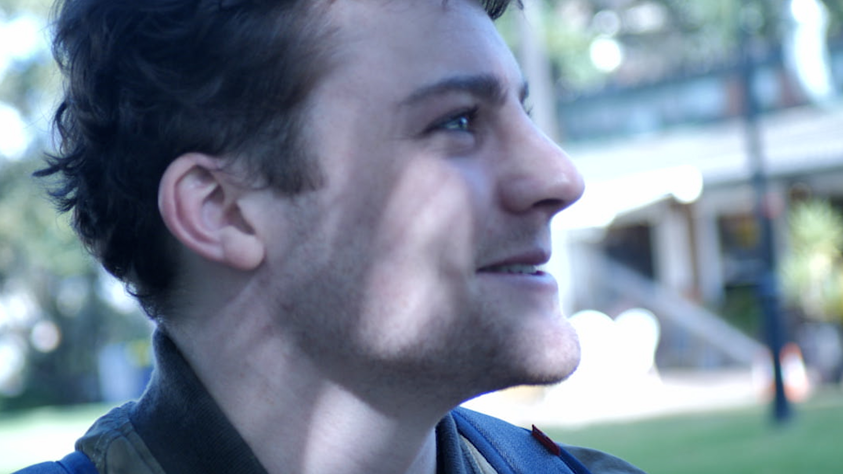

Friend (Matias)
This supporting role is the ambiguous friend of Sol, who is not exactly supporting him, since he is a disbeliever of Sol’s change of attitude.
Being fed up with his friend’s behaviours and habits, he ends up being critical and strict with him. Yet, somehow that works well for the couple in the end, since his behaviour makes him a catalyst and pushes forward the situation his friend is in.

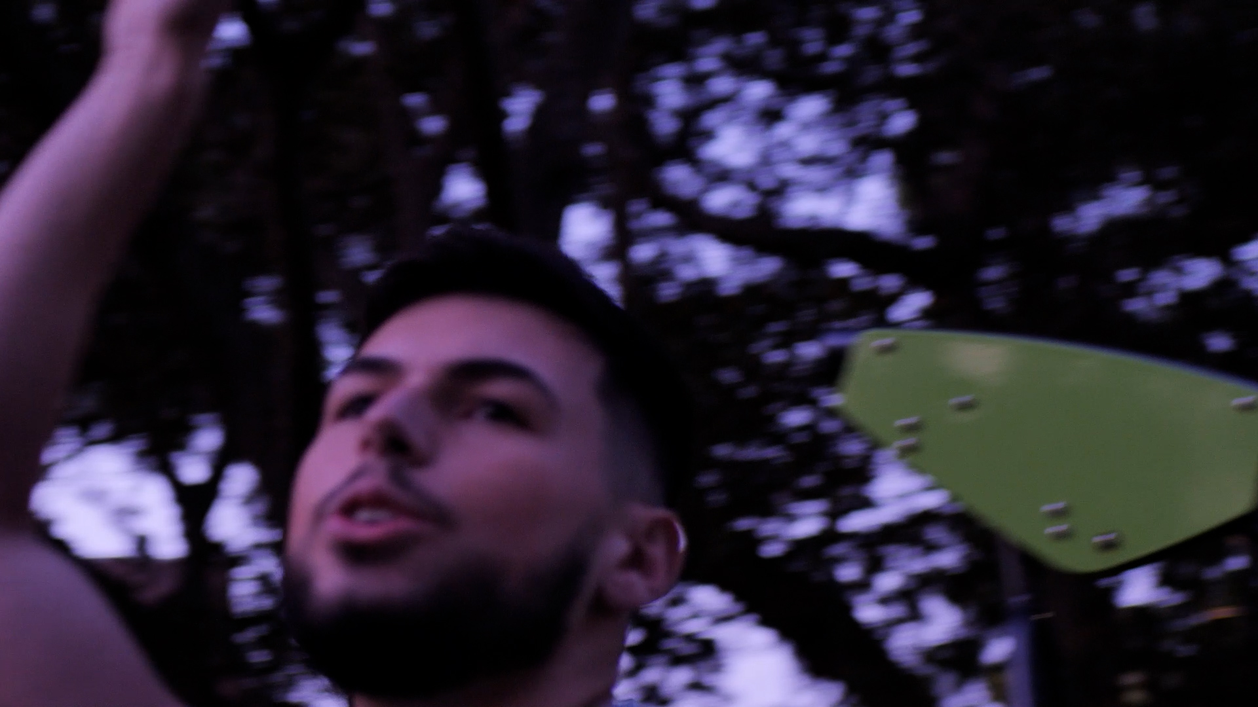

Q&A

- Q. Why did you insist on shooting the film by yourself when it was outlined to you to get an experienced producer by people you respect in the field?
  - It is true that I shot this film by myself in spite the difficulties I encountered, mainly technically and psychologically. I feel I have improved since my last short student film (this is my first short film after the Master’s degree in Moving Image at USYD) and even though I didn’t overcome all my problems and didn’t reach my anticipated goals as a camera operator, I set myself on a road where my skills can only improve and I am constantly gaining knowledge and awareness of what I am doing.

- Q. How did you finance this film?
  - The script is mine. Then I rented for six months the gear considered, at this point of my development as a filmmaker/artist, essential. This included a camera GH5 plus two lenses (a 25mm, f.1.7, and a standard zoom lens 12-60mm, f.2.8). Then I engaged in my shots the gimbal Ronin sc. As for the audio I used the wireless Rode 2 go mics, connected with a zoom recorder H6 to avoid the slight buzzing. I could afford the rental of 120 euros a month. Other than that, I shot and edited, and the actors were promised part of potential profits over the film instead of being hired on a pay day basis. I only paid them 250 aud on the day of the reshoot. (The two protagonists).
  - I did not try to request any funding, since I don’t belong to a particular sensitive group other than my bilingual background of Greek/Australian, nor had the time to wait passively for funds to arrive (if ever) and spared myself the attached disappointment if rejected.
After all, what does independent filmmaking mean at the end of the day?

- Q. Usually the man does not call the woman after having sex on the first date. So, it looks like the date was successful. What was it about the date that prompted him to call her for a next date?
  - Here the movie tackles on a sense of faith being built between these two people,
and creates a different kind of fairy tale based on contemporary exchange between the human beings of today?

4. Q. How hopeful are you about romantic relationships and their chances of success in the modern world?
A. I am in this game myself and I wish it weren’t a game or at least I don’t like seeing it in this way. As for my feelings, they go through a vedalia, from hope to bewilderness and back, with a lot of nuances in-between.
5. Q. Why did you decide to have an optimistic ending to your film when you personally you have a rather pessimistic view?
A. This film contributes as a valuable weight, to bring a balance exactly between these different views.

Director’s statement

…to be continued

